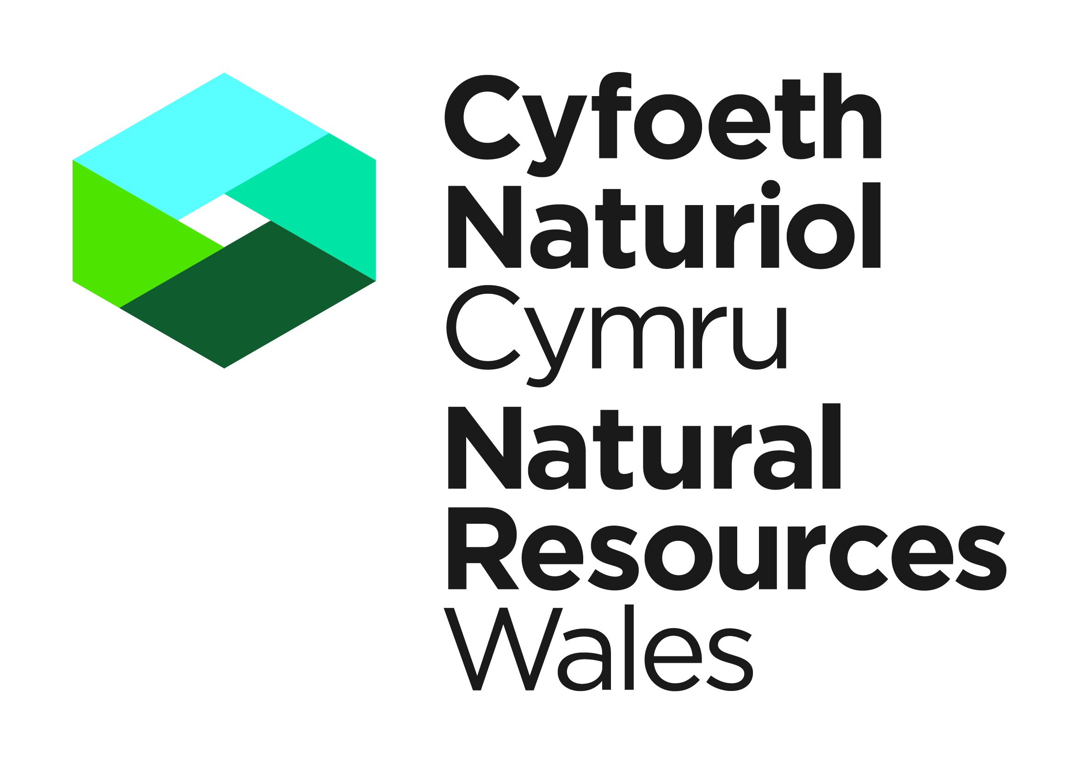


Template Method Statement to be used within a Great Crested Newt Development Licence Application

This template Method Statement is to be used to form part of your Licence Application for a European Protected Species Development Licence. It will be used to determine the impact of the application on the favourable conservation status of the species concerned (Regulation 55(9) (b) of the Conservation of Habitats and Species Regulations 2017). It must be prepared by a consultant ecologist of other suitably qualified person. You are strongly advised to refer to the Great Crested Newt Mitigation Guidelines. Please submit your Application and supporting Method Statement electronically to the contact details provided below.

Please note as of the 1st March 2018 the declaration box found at the end of this template must be included on any Method Statements submitted in support of a licence application, and must be signed and dated by the applicant and ecologist. Any application containing a Method Statement without this declaration will be rejected.

Contact Details

Natural Resources Wales
Species Permitting Team
Maes Y Ffynnon
Penrhosgarnedd
Bangor
LL57 2DW

03000 654974 / 03000 654921
specieslicence@naturalresourceswales.gov.uk
trwyddedrhywogaeth@cyfoethnaturiolcymru.gov.uk

Method Statement Title:

Method Statement Version Number:

Method Statement Issue Date:
Site Address:

Background and Supporting Information
A Executive Summary.
No more than one side of A4

B Introduction
B.1 Background to activity/development
Include a brief summary of what the proposed activity is and why it is necessary.
B.2 Full details of proposed works on site that are to be covered by the licence
Please ensure sufficent detail is provided on the proposed works e.g. construction of buildings, roads, fences etc. Include current status of planning permission or other consents (if applicable) and any outstanding conditions/reserved matters. Include timescales and order of work.
B.3 Actions requiring licensing
E.g. disturb, capture, translocate, damage or destroy breeding site or resting place (terrestrial and/or aquatic ), kill. Briefly explain why these actions are necessary.

C Survey and site assessment
C.1 Existing information on great crested newts at the survey site.
Provide records from local environmental records centres, predictive modelling, local herptile groups, previous survey work by the applicant or others. Include records from within 2km.
C.2 Statutory sites notified for the species (SSSIs or SACs) within 10km
C.3 Objectives of the survey
E.g. to determine presence/absence of all sub-populations of great crested newts likely to be affected, an estimate of population size and their usage of site (e.g. breeding, hibernation, and foraging).
C.4 Scaled plan/map of survey area
This should be of appropriate scale and orientation with integral or separate location map at 1:50,000 or 1:25,000 scale and aerial photographs.
C.5 Site/habitat description (relevant to great crested newts)
This should be based on day-time visits (to include description of site and habitat relevant to great crested newt ecology). Include annotated photographs if applicable.
C.6 Field survey(s).
Include survey method (night counts, bottle trapping,egg surveys, site inspections), timings (day/evening), weather conditions (wind, rain, air and water temperature – tabulated for multiple survey visits), personnel involved (provide individual licence numbers, if held) and details of experience/competence in this type of work, and equipment used (type and power of torch). Also record any occurrence of non-native invasive plant species or fish, and structures or features that may cause incidental capture or killing, e.g. gulley pots. Also include any constraints and justifications for departures from best practice.
C.7 Survey Results.
Summarise findings in table form (if appropriate); provide clear, annotated and cross-referenced maps/plans/photographs to show locations of breeding sites, and habitat maps. Raw data to be appended.
C.8 Interpretation/evaluation of survey results (Great crested newt Mitigation Guidelines section 5.8)
Provide count/estimate of great crested newt numbers, status of site (e.g. breeding, foraging, resting or hibernating), population significance, constraints on survey (e.g. time of year, cold weather, access problems – justify as necessary).

D Impact assessment – potential impact of proposed works in absence of mitigation/compensation. See Great Crested Newt Mitigation Guidelines (section 6.2)
D.1 Short-term impacts: disturbance
E.g. artificial light, restricting access to feeding or breeding sites, sheltering habitats and dispersal corridors.
D.2 Long-term impacts: site modification
E.g. destruction or damage of part of breeding site or preferential sheltering/foraging habitats Note that impacts can be positive or negative as this is in absence of mitigation.
D.3 Long-term impacts: site loss
Impact on different sub populations to be taken into account at 2km, 10km, local, regional, and national level.
D.4 Long-term impacts: fragmentation and isolation
E.g. loss of ponds or terrestrial habitat including stepping stones and linear features such as hedges, tree lines, severance of migration routes by roads.
D.5 Post-development interference impacts
E.g. gulley pots or other features that could effect incidental capture or killing, predation, disturbance, including those associated with recreation and human pressure,.
D.6 Predicted scale of impact
Include impacts on species status at the site, 2km, 10km, local, county, regional and country levels.

Delivery Information - Mitigation, compensation and monitoring
Description of how the impacts will be addressed in order to ensure no detriment to the maintenance of the population at a favourable conservation status.
E Works to be undertaken
Please identify which works will be undertaken or supervised by a licensed ecologist
E.1 Great Crested Newt capture and exclusion (if applicable).
Timings, effort, methods to be employed, reasonable avoidance schemes or measures for great crested newts (fencing, fence maintenance, logging captures, inspection and maintenance of fences), locations of receptor sites etc. Include diagrams to show locations of draft and exclusion fencing, pitfall trap design and trap density. State if site based weather stations are used to demonstrate appropriate trapping conditions
E.2 Great Crested Newt habitat
E.2.1 Receptor site modification, enhancement or creation.
Include details of new breeding sites and resting places e.g pond creation- design, layout, number, planting schemes, water supply and hydrology regimes, terrestrial habitat diversification or creation – design, habitat type, planting schemes, provenance of imported plants, consideration of biosecurity impacts.
E.2.2 Temporary loss of breeding sites, resting places
Provide details of all reasonable avoidance measures to be undertaken throughout the period of works
E.2.3 Destruction of existing breeding sites, resting places
Full project programme including dewatering schemes(including filter specifications), programmes of terrestrial searches, fencing location and construction, transport methodologies, void infilling.
E.2.4 Scaled maps/plans
To show proposals for mitigation outlined above in relation to existing and proposed habitat features and in relation to the proposed development outline. A GIS data layer may be included with your application to illustrate locations of habitats in E.2.1 to E.2.3

E.3 Mechanisms for ensuring delivery of mitigation and compensation measures

E.3.1 Measures to ensure compliance with this method statement.

This may require appointment of an external auditing scheme including audit key performance indicators, for medium, large scale or long term schemes e.g. residential development, pipeline construction or maintenance, way leaves for utilities, quarrying and mineral extraction.

E.3.2 Ensure that sufficient land has been acquired for compensation purposes

Provide scaled maps/plans
E.3.3 Ensure that designs of subsequent development are newt friendly
Do not include features likely to result in incidental capture or killing
E.3.4 Provide sufficient resources
To ensure effective site management and associated wardening and monitoring where relevant.
E.4 Mitigation contingencies
Describe any contingency proposals including circumstances when the contingencies will be instigated.

E.5 Biosecurity risk assessment
Consider presence of non-native species and disease on site and actions to be undertaken that will prevent their spread onto or off the site

F Post-development site safeguard
F.1 Habitat/site management and maintenance
Include ongoing land management proposals, details of who will be responsible for management and maintenance, on going running costs, site/structure ownership and monitoring development of new habitats.
F.2 Population monitoring
Include details of monitoring effort and timing, personnel involved and equipment to be used.
F.3 Post-development mitigation contingencies
Describe the action that you will take if monitoring results are unfavourable.
F.4 Mechanism for ensuring delivery of post-development works
As appropriate e.g. Section 106 Agreement, to include details of who will undertake the work and reporting details, other covenants, contractual agreements or wardening schemes.

G Timetable of works
Include timings of all capture, development activities and mitigation measures, monitoring and other post development works

H Land Ownership – Mitigation Site/Compensation Site
H.1 Mitigation Site/Compensation Site Ownership
If mitigation is to be undertaken at a location not owned by the applicant, you must provide the written consent of the relevant land owner(s). You must also provide details of how the mitigation is to be maintained in the long term (e.g. a legal agreement, transfer of legal interest).
H.2 Mitigation Site/Compensation Ownership post construction
If the ownership of the mitigation site will change after construction please confirm the identity of the prospective owners/occupiers together with timescales associated with transfer of occupancy or other forms of legal interest. You must also provide details of how the mitigation is to be maintained in the long term (e.g. a legal agreement).

I Declaration

I declare that should a licence be granted, the work as proposed in this Method Statement will be strictly adhered to. I understand that any deviation from the works as proposed in this Method Statement without agreement from NRW would result in a breach of the licence.

NB. Applicants should note that it is an offence under regulation 59 of the Conservation of Habitats and Species Regulations 2017 to knowingly or recklessly provide false information in order to obtain a licence.

Signature of the Applicant |  | Date
For electronic submissions please insert an electronic signature above or place an x in the box opposite to confirm agreement with the declarations above. |  |  | ☐
Full name in BLOCK LETTERS
Signature of the Ecologist |  | Date
For electronic submissions please insert an electronic signature above or place an x in the box opposite to confirm agreement with the declarations above. |  |  | ☐
Full name in BLOCK LETTERS
J References
Credits for source information.
K Annexes
K.1 Pre-existing survey reports
K.2 Raw survey data

Great Crested Newt Mitigation Guidelines (NEWT1) available from Natural England website

