Coed y Brenin Conference Room Booking Form

BOOKING TERMS & CONDITIONS
Please read the terms and conditions carefully before confirming your requirements, thank you.

Provisional Bookings
Due to demand for meeting rooms, please note that provisional bookings will only be kept for 48 hours. If a completed booking form is not received within this time alongside payment, the booking will be cancelled.

Cancelation Policy
Any cancellations should reach us 48 hours prior to meeting. If we do not receive cancellation notice 48 hours prior, we reserve the right to charge you for the room booking.

Additional Charges
Car parking charges are not included in the price of your booking - please ensure your attendees are aware of this prior to arrival. We encourage delegates to car share wherever possible.

Conference Room (Cadair Idris) Flat Fee for Hire £150
80 delegates (theatre style) or 50 delegates (workshop style)

Please provide full details to ensure we can accommodate your requirements.
Please send your completed booking form to the below email address to confirm payment and booking: ymholiadau@cyfoethnaturiolcymru.gov.uk /email: enquiries@naturalresourceswales.gov.uk Ffôn /phone: 0300 065 3000

Date of Meeting:

Organisation:

Booking in the name of:

Telephone No:

Mobile No:

Email:
Contact Name on the Day:
Time Room Required: | From: ………… (am/pm) To: ………. (am/pm)
Number Attending:
Type of event: | The room can accommodate the below set up profiles. Meeting / Conference / Workshop/ Social  You will be required to set up the room to your chosen profile on arrival. NRW will not take responsibility for the set up.  You do not need to take down room at the end of your session.  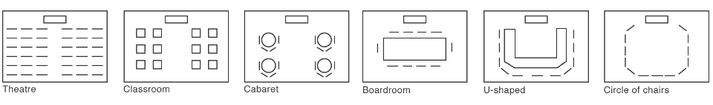

Invoice Address:

Please include Ref/ PO no.

Office Use
Room charge:
Total:
Date Sent to a/c:

