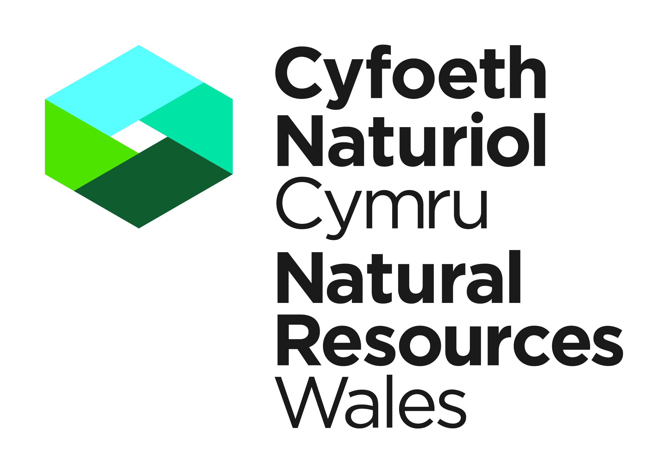


Template Method Statement to be used within a Dormice Development Licence Application

This template Method Statement is to be used to form part of your Licence Application for a European Protected Species Development Licence. It will be used to determine the impact of the application on the favourable conservation status of the species concerned (Regulation 55(9) (b) of the Conservation of Habitats and Species Regulations 2017). It must be prepared by a consultant ecologist of other suitably qualified person. You are strongly advised to refer to the Dormouse Conservation Handbook (2nd edition). Please submit your Application and supporting Method Statement electronically to the contact details provided below.

Please note as of the 1st March 2018 the declaration box found at the end of this template must be included on any Method Statements submitted in support of a licence application, and must be signed and dated by the applicant and ecologist. Any application containing a Method Statement without this declaration will be rejected.

Contact Details

Natural Resources Wales
Species Permitting Team
Maes Y Ffynnon
Penrhosgarnedd
Bangor
LL57 2DW

03000 654974 / 03000 654921
specieslicence@naturalresourceswales.gov.uk
trwyddedrhywogaeth@cyfoethnaturiolcymru.gov.uk

Method Statement Title:

Method Statement Version Number:

Method Statement Issue Date:
Site Address:

Background and Supporting Information
A Executive Summary.
No more than one side of A4

B Introduction
B.1 Background to activity/development
Include a brief summary of what the proposed activity is and why it is necessary.
B.2 Full details of proposed works on site that are to be covered by the licence
Please ensure sufficent detail is provided on the proposed works e.g. construction of buildings, roads, fences etc. Include current status of planning permission or other consents (if applicable) and any outstanding conditions/reserved matters. Include timescales and order of work.
B.3 Actions requiring licensing
E.g. disturb, capture, translocate, damage or destroy breeding site or resting place, kill. Briefly explain why these actions are necessary.

C Survey and site assessment
C.1 Existing information on the dormice at the survey site.
Provide records from local environmental records centres, local mammal group and previous survey work by the applicant or others. Include records from within 2km.
C.2 Statutory sites notified for the species (SSSIs) within 10km
C.3 Objectives of any specific survey
E.g. to determine presence/absence of dormice, dormouse usage of site (e.g. hibernation, breeding, foraging) or to estimate population size.
C.4 Scaled plan/map of survey area
This should be of appropriate scale and orientation with integral or separate location map at 1:50,000 or 1:25,000 scale and aerial photographs.
C.5 Site/habitat description (relevant to dormice).
Include annotated photographs if applicable and aerial photographs if available (to show habitat connectivity).
C.6 Field survey(s).
Include survey method, timings, weather conditions (wind, rain, temperature – tabulated for multiple survey visits), personnel involved (provide individual licence numbers, if held) and details of experience/competence in this type of work, and equipment used. Also include any constraints and justifications for departures from best practice.
C.7 Survey results.
Summarise findings in table form (if appropriate); provide clear, annotated, and cross-referenced maps/plans/photographs. Raw data to be appended.
C.8 Interpretation/evaluation of survey results
Provide best estimate of dormouse numbers based on data collected and available habitat, status and significance of population and habitat.

D Impact assessment – potential impacts of proposed works in absence of mitigation/compensation.
D.1 Short-term impacts: disturbance
E.g. noise, vibration, dust
D.2 Long-term impacts: habitat modification.
Note that impacts can be positive or negative as this is in absence of mitigation.
D.3 Long-term impacts: habitat loss.
Impact on populations to be taken into account at local, regional, and national level.
D.4 Long-term impacts: fragmentation and isolation
E.g. loss of linear features such as hedges, tree lines.
D.5 Post-development impacts
E.g. disturbance, predation.
D.6 Predicted scale of impact
Include impacts on the species status at the site, local county and regional levels.
Include a scaled plan/s showing location and extent of vegetation to be cleared in the context of the current site, results of the survey information etc.

Delivery Information – Mitigation, compensation and monitoring
Description of how the impacts will be addressed in order to ensure no detriment to the maintenance of the population at a favourable conservation status.

E Works to be undertaken
Please identify which works will be undertaken or supervised by a licensed ecologist
E.1 Site clearance methods
Include measures to avoid killing or injuring dormice, timings, effort and methods to be employed. Details of methodology on encountering active or hibernating dormice as applicable must be included.

E.2 Dormice habitat
E.2.1 In-situ retention of habitat
Specify area and composition of habitat that will be retained.
E.2.2 Modification of existing habitat
E.g. Coppicing, hedge laying, canopy thinning of standards, interplanting etc.
E.2.3 New habitat creation (including dormouse boxes)
Specify areas, composition, locations and timings of new habitat creation. Location details and number of boxes to be deployed.
E.2.4 Habitat losses and gains summary table
Summarise the areas of habitat to be retained, removed, enhanced or created.
E.2.5 Scaled maps/drawings
To show proposals for mitigation outlined above in relation to existing and proposed habitat features and in relation to the proposed development outline. A GIS data layer may be included with your application to illustrate locations of habitats in E.2.1 to E.2.3.

E.3 Mechanisms for ensuring delivery of mitigation and compensation measures

Include measures to ensure compliance with this method statement
E.4 Mitigation contingencies
Describe any contingency proposals including circumstances when the contingencies will be instigated.

E.5 Biosecurity risk assessment
Consider presence of non-native species and disease on site and actions to be undertaken that will prevent their spread onto or off the site

F Post-development site safeguard
F.1 Habitat/site management and maintenance
Include ongoing land management proposals, details of who will be responsible for management and maintenance, on going running costs, site/structure ownership and monitoring development of new habitats.
F.2 Population and habitat monitoring
Include details of effort and timing for the monitoring programmes of both the dormouse population and dormouse habitat (modified and newly planted).
F.3 Post-development mitigation contingencies
Describe the action that you will take if monitoring results are unfavourable.
F.4 Mechanism for ensuring delivery of post-development works
As appropriate e.g. Section 106 Agreement, to include details of who will undertake the work and reporting details, other covenants, contractual agreements or wardening schemes.

G Timetable of works
Include timings of habitat clearance and development activities, mitigation measures, monitoring and other post development works.

H Land Ownership – Mitigation Site/Compensation Site
H.1 Mitigation Site/Compensation Site Ownership
If mitigation is to be undertaken at a location not owned by the applicant, you must provide the written consent of the relevant land owner(s). You must also provide details of how the mitigation is to be maintained in the long term (e.g. a legal agreement).
H.2 Mitigation Site/Compensation Ownership post construction
If the ownership of the mitigation site will change after construction please confirm the identity of the prospective owners/occupiers together with timescales associated with transfer of occupancy. You must also provide details of how the mitigation is to be maintained in the long term (e.g. a legal agreement).
I declare that should a licence be granted, the work as proposed in this Method Statement will be strictly adhered to. I understand that any deviation from the works as proposed in this Method Statement without agreement from NRW would result in a breach of the licence.

NB. Applicants should note that it is an offence under regulation 59 of the Conservation of Habitats and Species Regulations 2017 to knowingly or recklessly provide false information in order to obtain a licence.

Signature of the Applicant |  | Date
For electronic submissions please insert an electronic signature above or place an x in the box opposite to confirm agreement with the declarations above. |  |  | ☐
Full name in BLOCK LETTERS
Signature of the Ecologist |  | Date
For electronic submissions please insert an electronic signature above or place an x in the box opposite to confirm agreement with the declarations above. |  |  | ☐
Full name in BLOCK LETTERS

I Declaration

J References
Credits for source information.
K Annexes
K.1 Pre-existing survey reports
K.2 Raw survey data

Dormouse Conservation Handbook (IN29) available to download from the Natural England website

